CS152

Human Computer Interaction

Dela Serna, Adrianne Faye

Javines, Kienth Justine

Dolorito, J-mar

June 28, 2024

**CHAPTER I. Introduction**

**Background of the Study**

The importance of mental health has become more crucial than ever in today’s world. The pressures of modern life, whether at work, home, or with friends, can have a significant impact on our well-being. Recognizing the need for better mental health support, the NeuroPal project was created. NeuroPal is designed to offer comprehensive tools and resources for managing mental health effectively. It is more than just an app; it's like a friend you can rely on for emotional support. With features like mood tracking, journaling, mindfulness exercises, and community support, NeuroPal provides a user-friendly platform to help improve mental health. The goal is to create a secure and supportive environment where users can express their feelings, set personal goals, and access professional help when needed.

Understanding the mental health challenges people face on a deeply personal level, NeuroPal aims to address these issues with empathy and care. The mood tracking feature lets users log their daily emotions, helping them see patterns over time. The journaling function provides a private space for reflecting on thoughts and experiences, promoting self-awareness and growth. Mindfulness exercises, such as guided meditations and breathing techniques, help manage stress and achieve mental clarity. Additionally, the community support feature encourages a sense of belonging and connection, allowing users to share their experiences and support each other. By integrating these features, NeuroPal aims to make a meaningful impact on mental well-being, helping individuals guide the hardship of modern life with more resilience and support.

**Statement of the Problem**

Even though there are many mental health resources available, people still find it hard to manage their mental well-being effectively. Most current mental health apps and tools are not easy to use or don't work well together, which means people don't use them as much as they could or don't get the support they need. Many individuals struggle with keeping track of their moods and mental health progress, finding helpful and reliable resources, and connecting with supportive communities. It's important to address these problems to help people better manage their mental health and get the comprehensive support they need.

**Assumption of the Study**

The NeuroPal project is built on several key assumptions that shape its development and ensure it meets the needs of people seeking mental health support.

First, we believe NeuroPal will make tracking daily moods much easier. The system is designed to simplify logging how you feel each day, adding details, and describing your emotions, so it takes less time and effort.

Second, we assume NeuroPal will provide a safe and effective space for journaling. Users will have a secure place to write about their experiences and thoughts, with tailored exercises to help guide their reflections and make journaling more beneficial.

Third, we are confident NeuroPal will have a user-friendly interface. The design will be simple and intuitive, catering to people with different levels of technical skill, so anyone can quickly learn how to use the app without needing extensive training.

Lastly, we expect NeuroPal to enhance the efficiency of managing mental health. The system aims to help users manage their well-being more productively by offering streamlined processes, automated features, and real-time data insights, ultimately leading to better mental health outcomes.

**SIGNIFICANCE OF THE STUDY**

Mental health support has reached an all-time high, offering tools and remedies for mental disorders and even mild mental health crises. This is where NEUROPAL by Void comes in: it helps people who struggle to manage their emotions and mental health, addressing the shortcomings of current software or apps that are too complicated and often hinder more than help the user. The user-friendly nature of NEUROPAL makes it significantly helpful in managing users' emotions and acts as a reliable companion whenever their feelings become overwhelming.

NEUROPAL can also enable advancements in software development for medical fields, particularly in mental health. In today's technologically dependent world, leveraging technology to support people in need, whether in small or big ways, is crucial. NEUROPAL proves to be a valuable tool that helps users take control of their feelings.

**Chapter II. Research Design**

**Task Analysis**

NeuroPal is a mental health app designed to support users in managing their mental well-being through various features. This Hierarchal Task Analysis (HTA) breaks down tasks into sub-tasks and operations. Below is the HTA for NeuroPal, focusing on key functionalities.

1. **Goal Setting and Tracking**
   1. **View and Track Goals:** On the home screen, users can view, add, edit, mark as done, and delete goals.
   2. **Add Goals:** Users will define the objective and timeline.
2. **Mental Health Metrics**
   1. **View mental health metrics:** Users can view their mental health metrics upon opening the app.
3. **Daily Mood Tracking & Journaling**
   1. **Log the current mood:** Users select their current mood from a predefined list of moods.
   2. **Write Journal:** Users can add a note or journal entry describing the context or events that influenced the mood. They can input text, images, or voice notes.
   3. **Save mood entry:** Users review the mood log and click the next button to proceed.
   4. **View calendar:** After saving the mood entry, users can view and navigate all the previous moods.
4. **Community Support**
   1. **Engage with the community:** Users can post questions, share experiences, participate in discussions or activities, or message friends.
5. **Void**
   1. **Send a message:** Users can input text or voice message and send it to the void for it to disappear in an instant.
6. **Time Capsule**
   1. **Create a new message:** Users can write a message for their future self. Optionally, they can add images, voice messages, images, or draw.
   2. **Set delivery date and email:** Select the date and time when the message should be delivered and add an extra email.
7. **Teletherapy**
   1. **Schedule a teletherapy session:** Users will first choose available therapists then choose a date and time for the session.
   2. **Connect with the therapist:** Users can message and connect with their therapist.
   3. **Attend the therapy session:** Users will receive a reminder notification and will participate in the video or audio call with the therapist.

**Requirements Gathering**

The team employed several methods to gather the necessary data for the NeuroPal proposal. These methods ensured a comprehensive understanding of user needs, functional specifications, and design constraints. The following sections detail how each method was utilized and tailored to our experience.

1. **Interview**

The group conducted semi-structured interviews with potential users, including students, mental health professionals, and educators. These interviews were designed to gather in-depth insights into the specific needs and challenges faced by the users.

1. **Survey/Questionnaire**

To reach a broader audience, the group distributed online surveys and questionnaires. These tools were instrumental in collecting quantitative data from a larger sample.

1. **Observation**

The group also conducted observational studies by shadowing students and professionals as they went about their daily routines. This method provided contextual insights that interviews and surveys might miss.

1. **Comparative Analysis of Existing Apps and Websites**

The group also conducted a comparative analysis of existing mental health apps and websites. This involved evaluating the features, design, and usability of popular mental health platforms to identify best practices and areas for improvement.

**Requirements**

1. **User Requirements**

From the users' perspective, the necessary requirements include:

* **Ease of Use:** The app must be intuitive and easy to navigate.
* **Privacy:** Users need assurance that their data is securely stored and handled with confidentiality.
* **Comprehensive Features:** Users expect a range of features, including mood tracking, journaling, goal setting, mindfulness exercises, community support, and access to educational resources.
* **Customization:** The ability to personalize the app according to individual preferences and needs.

1. **Functional Requirements**

These requirements define the core functionalities the app must provide:

* **Mood Tracking:** Allow users to log their mood daily with options for detailed entries.
* **Journaling**: Provide a secure space for users to write, save, and edit journal entries.
* **Mindfulness Exercises:** Offer guided exercises for stress relief and mindfulness practice.
* **Goal Setting and Tracking:** Enable users to set, break down, and track progress towards personal and academic goals.
* **Community Support:** Facilitate interaction with support groups and forums within the app.
* **Educational Resources:** Provide access to articles, videos, and other materials on mental health topics.

1. **Data Requirements**

The app must handle data efficiently and securely:

* **User Data:** Collect and store user profiles, mood logs, journal entries, goals, and interaction data.
* **Security:** Implement robust encryption and security measures to protect user data.
* **Analytics:** Gather and analyze usage data to improve app functionality and user experience.

1. **Environmental Requirements**

These requirements consider the environment in which the app will be used:

* **Device Compatibility:** Support a wide range of devices, including smartphones, tablets, and desktops.
* **Operating Systems:** Ensure compatibility with major operating systems like iOS, Android, Windows, and macOS.
* **Offline Functionality:** Provide basic functionalities that can be accessed offline, such as journaling and mood tracking.

1. **Usability Requirements**

These requirements focus on the user experience:

* **User Interface:** Design a clean, intuitive, and visually appealing interface.
* **Accessibility**: Make the app accessible to users with disabilities, following guidelines such as WCAG (Web Content Accessibility Guidelines).
* **Feedback Mechanisms:** Include feedback mechanisms for users to report issues and suggest improvements.

1. **Designers Requirements**

From the designers' perspective, the requirements include:

* **Consistency**: Maintain a consistent design language across the app to ensure a seamless user experience.
* **Scalability**: Design the app architecture to handle an increasing number of users and data without compromising performance.
* **Innovation**: Incorporate innovative features and design elements to distinguish NeuroPal from other mental health apps.
* **Iterative Design**: Implement an iterative design process, continuously improving the app based on user feedback and testing results.

**Storyboarding and Prototyping**

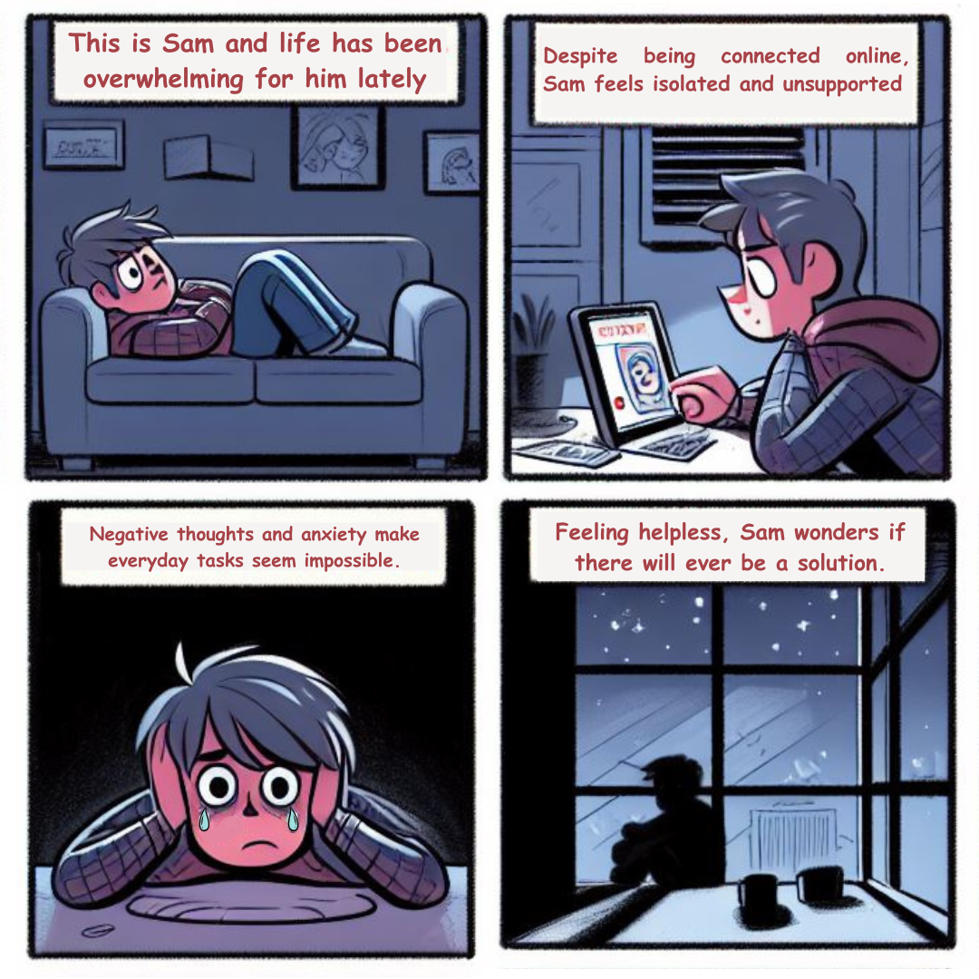

**Prototype**

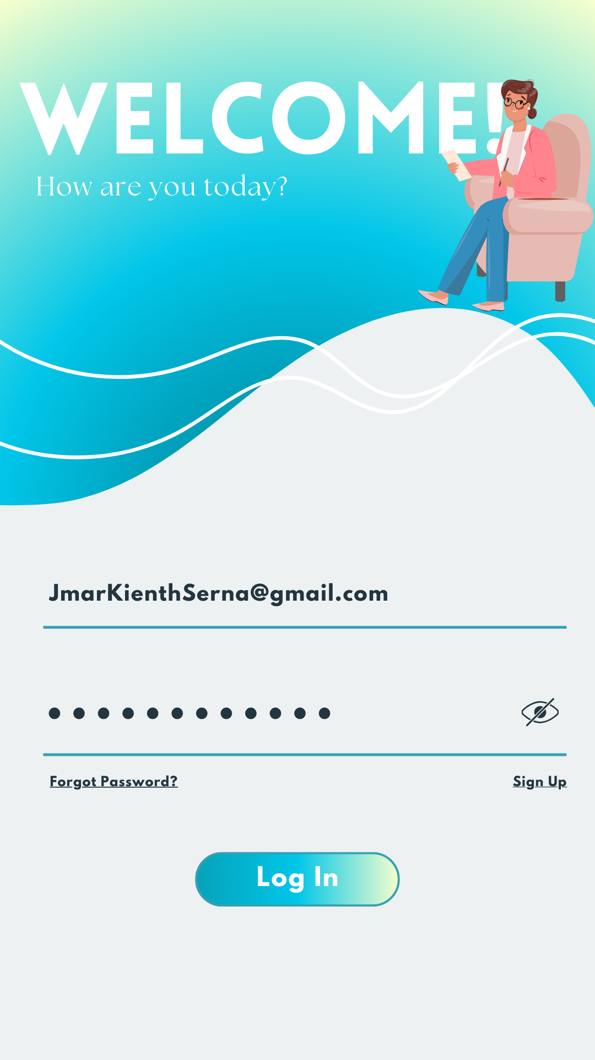**Log In Page**  
This page allows users to input their account details to securely log in and access their personalized dashboard. New users can easily sign up by providing their information, ensuring a seamless and efficient onboarding process. Sign in or create an account to unlock all the features and benefits our platform has to offer.

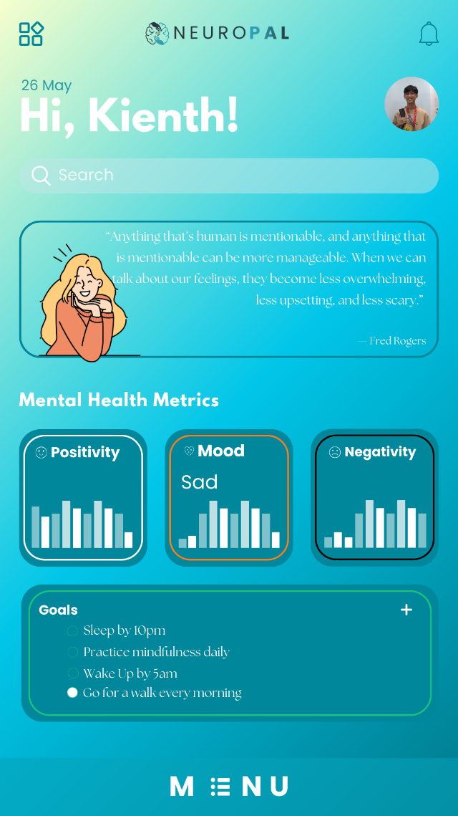

**Main Page**

The main page provides a comprehensive view of your mental health metrics, including graphs that track positivity, mood, and negativity based on this month's records. You can set and monitor your personal goals, receive daily mental health quotes for inspiration, and utilize the search bar to quickly find specific features within the app. Stay informed and motivated with easy access to all your mental wellness tools in one place.

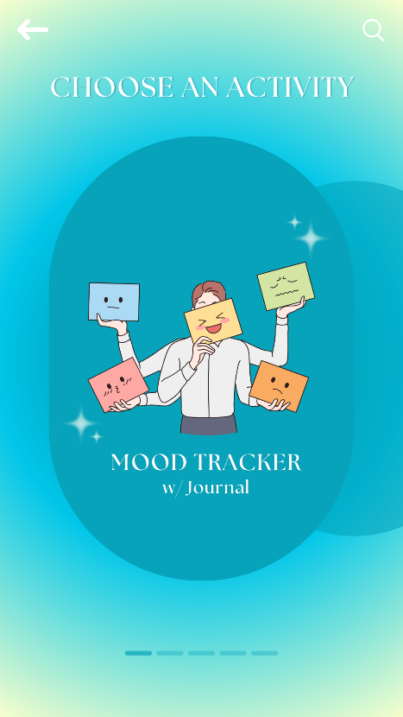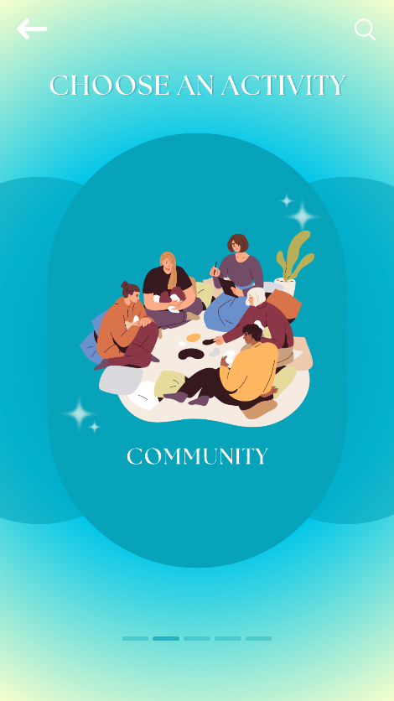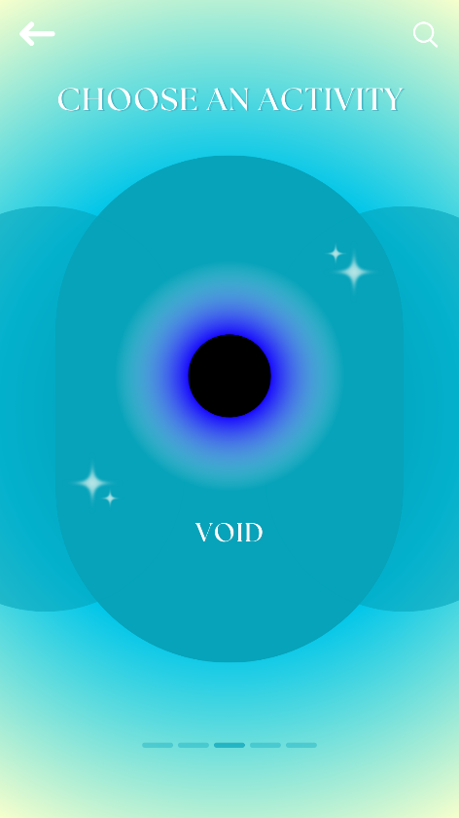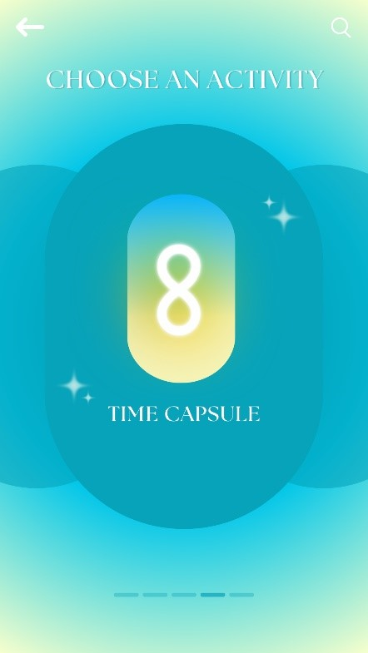 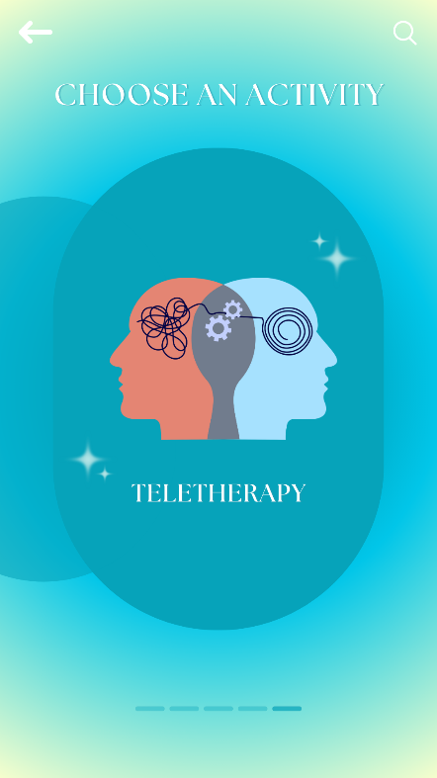

**Menu Page**

This menu page features a vibrant and intuitive design that invites users to choose an activity tailored to their mental health needs. The background gradient transitions smoothly from a calming light yellow to a serene blue, creating a soothing visual experience. At the center, an engaging illustration depicts a character holding various mood icons, emphasizing the mood tracker with a journal. The clean typography and easily recognizable icons ensure that users can navigate the menu effortlessly. Additional activities like community engagement, the void for personal reflections, time capsule, and teletherapy can be accessed via the search bar or by swiping through the options, making it simple and enjoyable to find and select the desired feature.

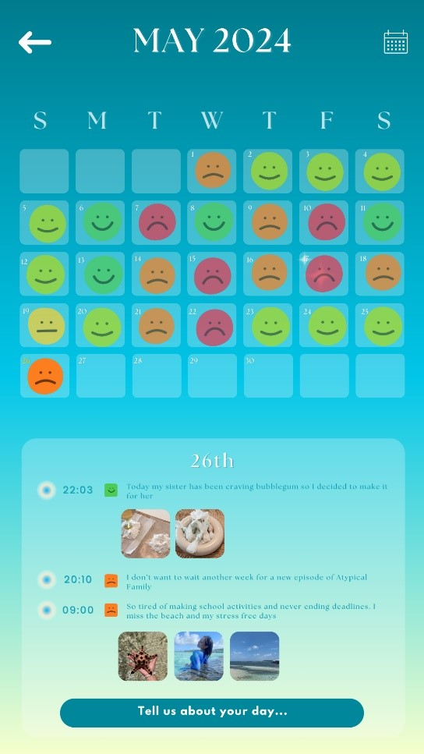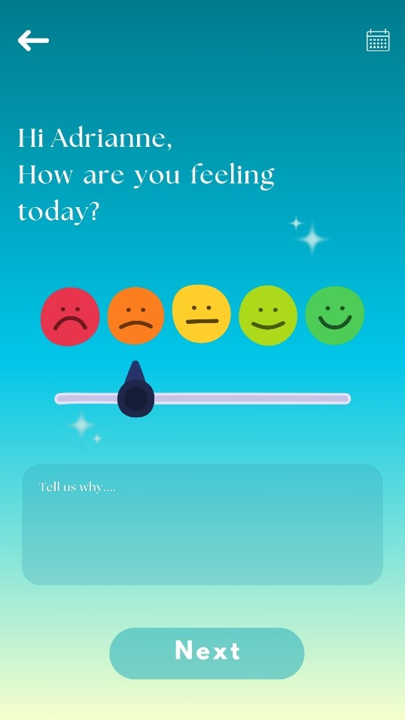

**Mood Tracker**

The mood tracker activity offers a user-friendly interface for tracking daily moods and journaling experiences. Upon opening, users are greeted with a question about their current feelings, which they can express through an intuitive slider featuring a range of emoticons. Below the slider, a text box invites users to share more details about their day. The calendar view on the second screen provides an at-a-glance overview of mood patterns over the month, with each day marked by a corresponding emoticon. Users can click on specific dates to see detailed entries, promoting self-reflection and emotional awareness.

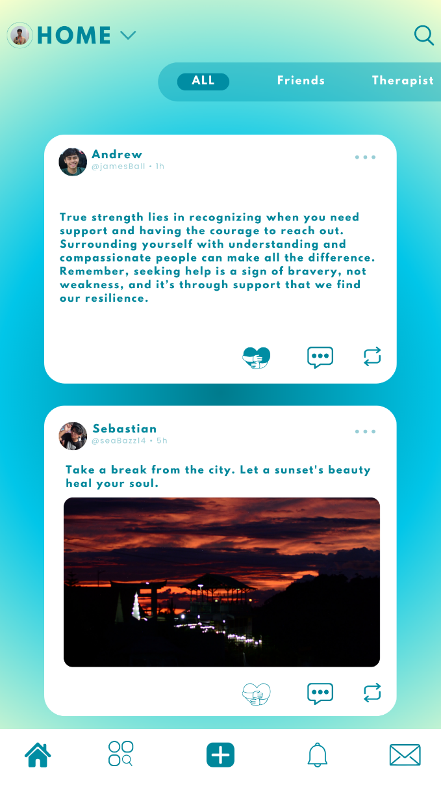< - **Community** The community page serves as the app's social feed, allowing users to connect and engage with posts from friends, therapists, and the broader community. The feed displays supportive messages and inspiring quotes, encouraging mental well-being and resilience. Users can easily switch between viewing all posts, posts from friends, or posts from their therapist. Interactive buttons allow for liking, commenting, and sharing posts, fostering a sense of community and mutual support within the app.

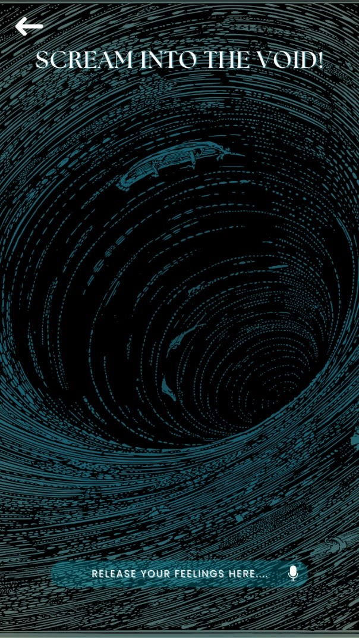**<- Void -**This page offers a unique emotional release feature called "Scream into the Void," where users can express their feelings freely and anonymously. The visually striking background of a swirling vortex symbolizes the intensity of emotions, providing a safe space for users to voice their frustrations or stress. By tapping the microphone icon, users can record their thoughts, helping them find a sense of relief and catharsis.

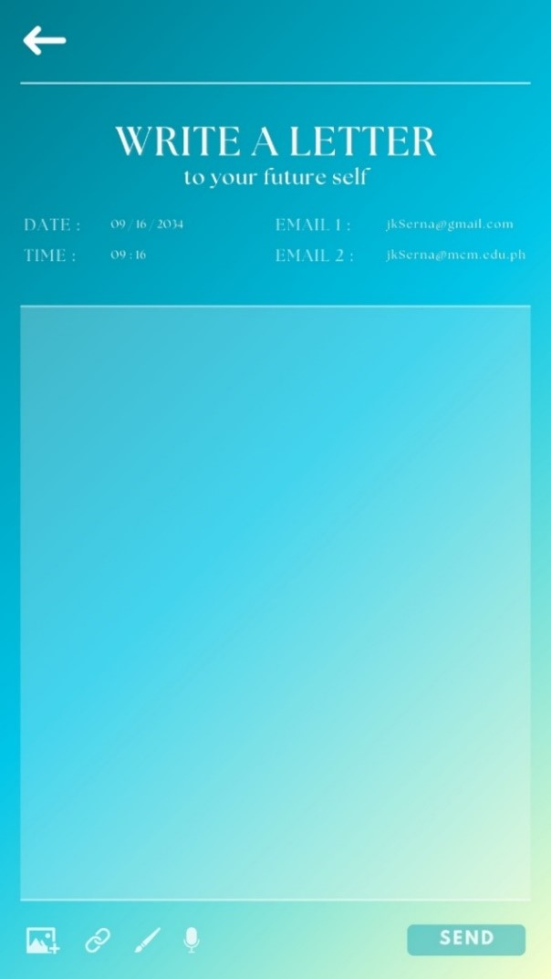**<-Time Capsule** The Time Capsule page lets the user write a letter to their future self. Users can choose a date and time for when they want the letter to be sent. The letter will be sent to the registered email of the account, but the user can also add another email in case of any future problems. Users can upload photos and videos, links, voice recordings, and even create paintings.

**Teletherapy->**

The Teletherapy page enables users to find and connect with a psychologist for consulting. Users can view detailed profiles of available psychologists, including their specialties and therapeutic approaches. Each profile includes an option to send a direct message for consultation. The page is designed to help users find the right psychologist for their specific needs, whether it be stress management, self-esteem issues, anxiety, ADHD, personality disorders, autism, trauma, depression, or cultural identity concerns.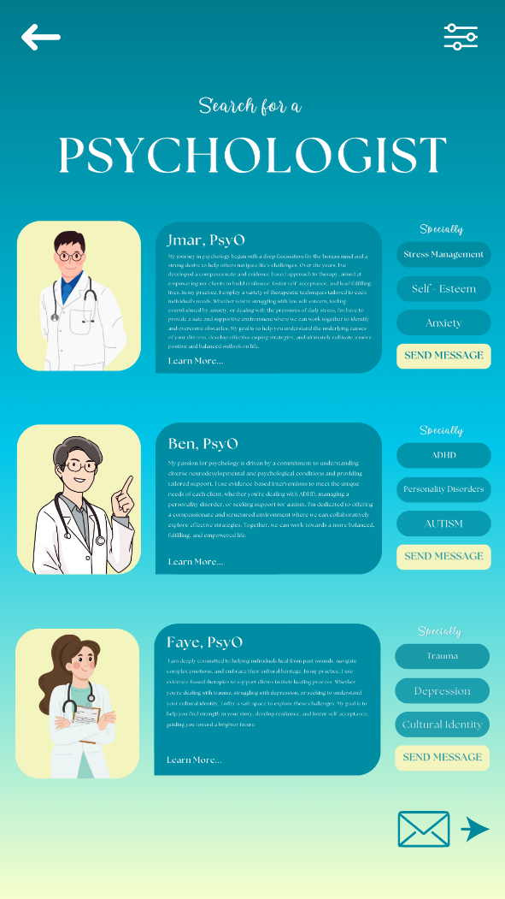

**Evaluation of Prototype**

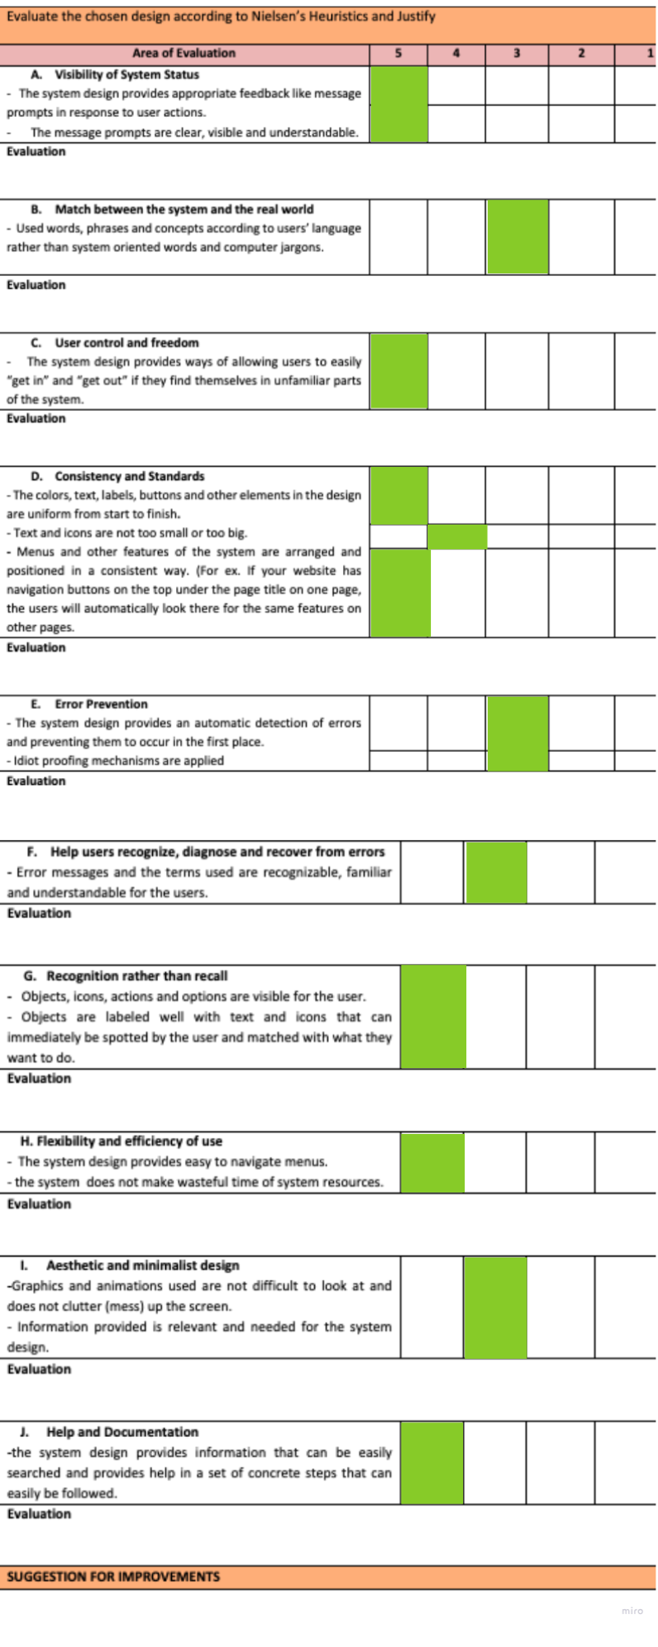

**Chapter III. Conclusion and Recommendation**

NEUROPAL creates new opportunities in software development to help stabilize and manage mental health. Guided by the vision of providing comprehensive yet concise mental health support, NEUROPAL offers user-friendly, state-of-the-art features and, most importantly, science-backed methods for dealing with emotions and mental instability. NEUROPAL is designed to afford non-tech-savvy individuals with mental health challenges a positive experience using the app. Advanced technologies ensure easy and efficient access, improving system performance for all users.

This logic underpins NEUROPAL’s ambitious mission. Soon, with the support of science and proven technology, NEUROPAL will be recognized by future generations as a template for solving widely recognized problems in the medical field. The associated software and proven research give NEUROPAL a competitive edge. NEUROPAL places new users first through its user-friendly design, AI-powered features, and state-of-the-art technologies, all within a mental health support framework.

While NEUROPAL might not be the leading mental health app today, it has the potential to achieve that status with a strong foundation, proper management, and continuous software updates. NEUROPAL does not aim to cure mental disorders but to assist and ease the challenges faced by users experiencing mental issues. Clear goals and a vision depict a bright future for NEUROPAL in helping those in need.

To realize its full potential, NEUROPAL should continue to fine-tune the user experience, ensuring ease of use regardless of age or technical skill. It should leverage new technologies by regularly updating the app with advancements in AI and mental health research. Engaging users for feedback and continuously developing the app to meet their needs is crucial. Expanding outreach to raise awareness and provide access to NEUROPAL will attract a broader audience, including those who do not typically use mental health apps. Lastly, collaborating closely with mental health professionals will ensure that the app’s features remain scientifically valid and beneficial. By following these recommendations, NEUROPAL can become an essential tool for promoting mental health and supporting emotional well-being.